Introduction to URDF: Mobile Robot Design and Control

Install few extensions in Visual Studio:
- Python extension
- XML extension
- URDF extension
- ICONS extension
- ROS extension

Install the necessary packages required
Execute in Terminal #1

sudo apt-get install ros-humble-teleop-twist-keyboard
sudo apt-get install ros-humble-joint-state-publisher*

sudo apt install gazebo
sudo apt install ros-humble-gazebo-ros-pkgs
sudo apt install ros-humble-robot-state-publisher*

Execute in Terminal #1

cd ros2_ws/src
ros2 pkg create lab4 --build-type ament_python --dependencies rclpy
cd src/lab4/
mkdir urdf
mkdir launch
cd urdf
touch three_wheeled_robot.urdf

<?xml version="1.0" ?>

<robot name = "three_wheeled_robot">

<link name="base">
<visual>
<geometry>
<box size="0.75 0.4 0.1"/>
</geometry>
<material name="gray">
<color rgba=".2 .2 .2 1" />
</material>
</visual>

<inertial>
<mass value="1" />
<inertia ixx="0.01" ixy="0.0" ixz="0" iyy="0.01" iyz="0" izz="0.01" />
</inertial>

<collision>
<geometry>
<box size="0.75 0.4 0.1"/>
</geometry>
</collision>

</link>

<link name="wheel_right_link">
<inertial>
<mass value="2" />
<inertia ixx="0.01" ixy="0.0" ixz="0"
iyy="0.01" iyz="0" izz="0.01" />
</inertial>

<visual>
<geometry>
<cylinder radius="0.15" length="0.1"/>
</geometry>
<material name="white">
<color rgba="1 1 1 1"/>
</material>
</visual>

<collision>
<geometry>
<cylinder radius="0.15" length="0.1"/>
</geometry>
<contact_coefficients mu="1" kp="1e+13" kd="1.0"/>
</collision>
</link>

<joint name="wheel_right_joint" type="continuous">
<origin xyz="0.2 0.25 0.0" rpy="1.57 0.0 0.0"/>
<parent link="base"/>
<child link="wheel_right_link"/>
<axis xyz="0.0 0.0 1.0"/>
</joint>

<link name="wheel_left_link">
<inertial>
<mass value="2" />
<inertia ixx="0.01" ixy="0.0" ixz="0"
iyy="0.01" iyz="0" izz="0.01" />
</inertial>

<visual>
<geometry>
<cylinder radius="0.15" length="0.1"/>
</geometry>
<material name="white">
<color rgba="1 1 1 1"/>
</material>
</visual>

<collision>
<geometry>
<cylinder radius="0.15" length="0.1"/>
</geometry>
<contact_coefficients mu="1" kp="1e+13" kd="1.0"/>
</collision>
</link>

<joint name="wheel_left_joint" type="continuous">
<origin xyz="0.2 -0.25 0.0" rpy="1.57 0.0 0.0"/>
<parent link="base"/>
<child link="wheel_left_link"/>
<axis xyz="0.0 0.0 1.0"/>
</joint>

<link name="caster">
<inertial>
<mass value="1" />
<inertia ixx="0.01" ixy="0.0" ixz="0"
iyy="0.01" iyz="0" izz="0.01" />
</inertial>

<visual>
<geometry>
<sphere radius=".08" />
</geometry>
<material name="white" />
</visual>

<collision>
<origin/>
<geometry>
<sphere radius=".08" />
</geometry>
</collision>
</link>

<joint name="caster_joint" type="continuous">
<origin xyz="-0.3 0.0 -0.07" rpy="0.0 0.0 0.0"/>
<axis xyz="0 0 1" />
<parent link="base"/>
<child link="caster"/>
</joint>

<link name="camera">
<inertial>
<mass value="0.1" />
<inertia ixx="0.01" ixy="0.0" ixz="0"
iyy="0.01" iyz="0" izz="0.01" />
</inertial>

<visual>
<geometry>
<box size="0.1 0.1 0.05"/>
</geometry>
<material name="white">
<color rgba="1 1 1 1"/>
</material>
</visual>

<collision>
<geometry>
<box size="0.1 0.1 0.05"/>
</geometry>
</collision>
</link>

<joint name="camera_joint" type="fixed">
<origin xyz="-0.35 0 0.01" rpy="0 0.0 3.14"/>
<parent link="base"/>
<child link="camera"/>
<axis xyz="0.0 0.0 1.0"/>
</joint>

<link name="lidar">
<inertial>
<mass value="0.5" />
<inertia ixx="0.01" ixy="0.0" ixz="0"
iyy="0.01" iyz="0" izz="0.01" />
</inertial>

<visual>
<geometry>
<cylinder radius="0.1" length="0.05"/>
</geometry>
<material name="white">
<color rgba="1 1 1 1"/>
</material>
</visual>

<collision>
<geometry>
<box size="0.1 0.1 0.1"/>
</geometry>
</collision>
</link>

<joint name="lidar_joint" type="fixed">
<origin xyz="-0.285 0 0.075" rpy="0 0.0 1.57"/>
<parent link="base"/>
<child link="lidar"/>
<axis xyz="0.0 0.0 1.0"/>

</joint>

<!--http://wiki.ros.org/simulator_gazebo/Tutorials/ListOfMaterials-->
<gazebo reference="base">
<material>Gazebo/WhiteGlow</material>
</gazebo>
<gazebo reference="wheel_left_link">
<material>Gazebo/SkyBlue</material>
</gazebo>
<gazebo reference="wheel_right_link">
<material>Gazebo/SkyBlue </material>
</gazebo>
<gazebo reference="caster">
<material>Gazebo/Grey</material>
</gazebo>
<gazebo reference="lidar">
<material>Gazebo/Blue</material>
</gazebo>
<gazebo reference="camera">
<material>Gazebo/Red</material>
</gazebo>

<!-- differential robot-->
<gazebo>
<plugin filename="libgazebo_ros_diff_drive.so" name="gazebo_base_controller">
<odometry_frame>odom</odometry_frame>
<commandTopic>cmd_vel</commandTopic>
<publish_odom>true</publish_odom>
<publish_odom_tf>true</publish_odom_tf>
<update_rate>15.0</update_rate>

<left_joint>wheel_left_joint</left_joint>
<right_joint>wheel_right_joint</right_joint>

<wheel_separation>0.5</wheel_separation>
<wheel_diameter>0.3</wheel_diameter>
<max_wheel_acceleration>0.7</max_wheel_acceleration>
<max_wheel_torque>8</max_wheel_torque>
<robotBaseFrame>base</robotBaseFrame>
</plugin>
</gazebo>

<!-- camera plugin-->
<gazebo reference="camera">
<sensor type="camera" name="camera1">
<visualize>true</visualize>
<update_rate>30.0</update_rate>
<camera name="head">
<horizontal_fov>1.3962634</horizontal_fov>
<image>
<width>800</width>
<height>800</height>
<format>R8G8B8</format>
</image>
<clip>
<near>0.02</near>
<far>300</far>
</clip>
</camera>
<plugin name="camera_controller" filename="libgazebo_ros_camera.so">
<alwaysOn>true</alwaysOn>
<updateRate>60.0</updateRate>
<cameraName>/camera1</cameraName>
<imageTopicName>image_raw</imageTopicName>
<cameraInfoTopicName>info_camera</cameraInfoTopicName>
<frameName>camera</frameName>
<hackBaseline>0.07</hackBaseline>
</plugin>
</sensor>
</gazebo>

<!--lidar plugin-->
<gazebo reference="lidar">
<sensor name="lidar" type="ray">
<visualize>true</visualize>
<update_rate>12.0</update_rate>
<plugin filename="libgazebo_ros_ray_sensor.so" name="gazebo_lidar">
<output_type>sensor_msgs/LaserScan</output_type>
<frame_name>lidar</frame_name>
</plugin>
<ray>
<scan>
<horizontal>
<samples>360</samples>
<resolution>1</resolution>
<min_angle>0.00</min_angle>
<max_angle>3.14</max_angle>
</horizontal>
</scan>
<range>
<min>0.120</min>
<max>3.5</max>
<resolution>0.015</resolution>
</range>
</ray>
</sensor>
</gazebo>

</robot>

cd ..
cd launch
touch gazebo.launch.py

from launch import LaunchDescription
from launch_ros.actions import Node
from launch.actions import ExecuteProcess
def generate_launch_description():
urdf = '/home/asha/ros2_ws/src/lab4/urdf/three_wheeled_robot.urdf'
return LaunchDescription([

Node(
package='robot_state_publisher',
executable='robot_state_publisher',
name='robot_state_publisher',
output='screen',
arguments=[urdf]),
Node(
package='joint_state_publisher',
executable='joint_state_publisher',
name='joint_state_publisher',
arguments=[urdf]),
# Gazebo related stuff required to launch the robot in simulation
ExecuteProcess(
cmd=['gazebo', '--verbose', '-s', 'libgazebo_ros_factory.so'],
output='screen'),
Node(
package='gazebo_ros',
executable='spawn_entity.py',
name='urdf_spawner',
output='screen',
arguments=["-topic", "/robot_description", "-entity", "lab4"])
])

touch rviz.launch.py

from launch import LaunchDescription
from launch_ros.actions import Node

def generate_launch_description():
urdf = '/home/asha/ros2_ws/src/lab4/urdf/three_wheeled_robot.urdf'
# rviz_config_file=os.path.join(package_dir,'config.rviz')

return LaunchDescription([
Node(
package='robot_state_publisher',
executable='robot_state_publisher',
name='robot_state_publisher',
output='screen',
arguments=[urdf]),
Node(
package='joint_state_publisher_gui',
executable='joint_state_publisher_gui',
name='joint_state_publisher_gui',
arguments=[urdf]),

Node(
package='rviz2',
executable='rviz2',
name='rviz2',
# arguments=['-d',rviz_config_file],
output='screen'),

])

Edit the setup.py file as

from setuptools import setup
import os
from glob import glob
package_name = 'lab4 '

setup(
name=package_name,
version='0.0.0',
packages=[package_name],
data_files=[
('share/ament_index/resource_index/packages',
['resource/' + package_name]),
('share/' + package_name, ['package.xml']),
(os.path.join('share', package_name), glob('urdf/*')),
(os.path.join('share', package_name), glob('launch/*'))
],
install_requires=['setuptools'],
zip_safe=True,
maintainer='asha',
maintainer_email='asha@todo.todo',
description='TODO: Package description',
license='TODO: License declaration',
tests_require=['pytest'],
entry_points={
'console_scripts': [
],
},
)

Execute in Terminal #1
colcon build --packages-select lab4
ros2 launch lab4 rviz.launch.py
Execute in Terminal #2
killall gzserver
ros2 launch lab4 gazebo.launch.py
Execute in Terminal #3
ros2 run teleop_twist_keyboard teleop_twist_keyboard
Edit the URDF file to add LIDAR and CAMERA links along with GAZEBO plugins.

<?xml version="1.0" ?>

<robot name = "three_wheeled_robot">

<link name="base">
<visual>
<geometry>
<box size="0.75 0.4 0.1"/>
</geometry>
<material name="gray">
<color rgba=".2 .2 .2 1" />
</material>
</visual>

<inertial>
<mass value="1" />
<inertia ixx="0.01" ixy="0.0" ixz="0" iyy="0.01" iyz="0" izz="0.01" />
</inertial>

<collision>
<geometry>
<box size="0.75 0.4 0.1"/>
</geometry>
</collision>

</link>

<link name="wheel_right_link">
<inertial>
<mass value="2" />
<inertia ixx="0.01" ixy="0.0" ixz="0"
iyy="0.01" iyz="0" izz="0.01" />
</inertial>

<visual>
<geometry>
<cylinder radius="0.15" length="0.1"/>
</geometry>
<material name="white">
<color rgba="1 1 1 1"/>
</material>
</visual>

<collision>
<geometry>
<cylinder radius="0.15" length="0.1"/>
</geometry>
<contact_coefficients mu="1" kp="1e+13" kd="1.0"/>
</collision>
</link>

<joint name="wheel_right_joint" type="continuous">
<origin xyz="0.2 0.25 0.0" rpy="1.57 0.0 0.0"/>
<parent link="base"/>
<child link="wheel_right_link"/>
<axis xyz="0.0 0.0 1.0"/>
</joint>

<link name="wheel_left_link">
<inertial>
<mass value="2" />
<inertia ixx="0.01" ixy="0.0" ixz="0"
iyy="0.01" iyz="0" izz="0.01" />
</inertial>

<visual>
<geometry>
<cylinder radius="0.15" length="0.1"/>
</geometry>
<material name="white">
<color rgba="1 1 1 1"/>
</material>
</visual>

<collision>
<geometry>
<cylinder radius="0.15" length="0.1"/>
</geometry>
<contact_coefficients mu="1" kp="1e+13" kd="1.0"/>
</collision>
</link>

<joint name="wheel_left_joint" type="continuous">
<origin xyz="0.2 -0.25 0.0" rpy="1.57 0.0 0.0"/>
<parent link="base"/>
<child link="wheel_left_link"/>
<axis xyz="0.0 0.0 1.0"/>
</joint>

<link name="caster">
<inertial>
<mass value="1" />
<inertia ixx="0.01" ixy="0.0" ixz="0"
iyy="0.01" iyz="0" izz="0.01" />
</inertial>

<visual>
<geometry>
<sphere radius=".08" />
</geometry>
<material name="white" />
</visual>

<collision>
<origin/>
<geometry>
<sphere radius=".08" />
</geometry>
</collision>
</link>

<joint name="caster_joint" type="continuous">
<origin xyz="-0.3 0.0 -0.07" rpy="0.0 0.0 0.0"/>
<axis xyz="0 0 1" />
<parent link="base"/>
<child link="caster"/>
</joint>

<link name="camera">
<inertial>
<mass value="0.1" />
<inertia ixx="0.01" ixy="0.0" ixz="0"
iyy="0.01" iyz="0" izz="0.01" />
</inertial>

<visual>
<geometry>
<box size="0.1 0.1 0.05"/>
</geometry>
<material name="white">
<color rgba="1 1 1 1"/>
</material>
</visual>

<collision>
<geometry>
<box size="0.1 0.1 0.05"/>
</geometry>
</collision>
</link>

<joint name="camera_joint" type="fixed">
<origin xyz="-0.35 0 0.01" rpy="0 0.0 3.14"/>
<parent link="base"/>
<child link="camera"/>
<axis xyz="0.0 0.0 1.0"/>
</joint>

<link name="lidar">
<inertial>
<mass value="0.5" />
<inertia ixx="0.01" ixy="0.0" ixz="0"
iyy="0.01" iyz="0" izz="0.01" />
</inertial>

<visual>
<geometry>
<cylinder radius="0.1" length="0.05"/>
</geometry>
<material name="white">
<color rgba="1 1 1 1"/>
</material>
</visual>

<collision>
<geometry>
<box size="0.1 0.1 0.1"/>
</geometry>
</collision>
</link>

<joint name="lidar_joint" type="fixed">
<origin xyz="-0.285 0 0.075" rpy="0 0.0 1.57"/>
<parent link="base"/>
<child link="lidar"/>
<axis xyz="0.0 0.0 1.0"/>

</joint>

<!--http://wiki.ros.org/simulator_gazebo/Tutorials/ListOfMaterials-->
<gazebo reference="base">
<material>Gazebo/WhiteGlow</material>
</gazebo>
<gazebo reference="wheel_left_link">
<material>Gazebo/SkyBlue</material>
</gazebo>
<gazebo reference="wheel_right_link">
<material>Gazebo/SkyBlue </material>
</gazebo>
<gazebo reference="caster">
<material>Gazebo/Grey</material>
</gazebo>
<gazebo reference="lidar">
<material>Gazebo/Blue</material>
</gazebo>
<gazebo reference="camera">
<material>Gazebo/Red</material>
</gazebo>

<!-- differential robot-->
<gazebo>
<plugin filename="libgazebo_ros_diff_drive.so" name="gazebo_base_controller">
<odometry_frame>odom</odometry_frame>
<commandTopic>cmd_vel</commandTopic>
<publish_odom>true</publish_odom>
<publish_odom_tf>true</publish_odom_tf>
<update_rate>15.0</update_rate>

<left_joint>wheel_left_joint</left_joint>
<right_joint>wheel_right_joint</right_joint>

<wheel_separation>0.5</wheel_separation>
<wheel_diameter>0.3</wheel_diameter>
<max_wheel_acceleration>0.7</max_wheel_acceleration>
<max_wheel_torque>8</max_wheel_torque>
<robotBaseFrame>base</robotBaseFrame>
</plugin>
</gazebo>

<!-- camera plugin-->
<gazebo reference="camera">
<sensor type="camera" name="camera1">
<visualize>true</visualize>
<update_rate>30.0</update_rate>
<camera name="head">
<horizontal_fov>1.3962634</horizontal_fov>
<image>
<width>800</width>
<height>800</height>
<format>R8G8B8</format>
</image>
<clip>
<near>0.02</near>
<far>300</far>
</clip>
</camera>
<plugin name="camera_controller" filename="libgazebo_ros_camera.so">
<alwaysOn>true</alwaysOn>
<updateRate>60.0</updateRate>
<cameraName>/camera1</cameraName>
<imageTopicName>image_raw</imageTopicName>
<cameraInfoTopicName>info_camera</cameraInfoTopicName>
<frameName>camera</frameName>
<hackBaseline>0.07</hackBaseline>
</plugin>
</sensor>
</gazebo>

<!--lidar plugin-->
<gazebo reference="lidar">
<sensor name="lidar" type="ray">
<visualize>true</visualize>
<update_rate>12.0</update_rate>
<plugin filename="libgazebo_ros_ray_sensor.so" name="gazebo_lidar">
<output_type>sensor_msgs/LaserScan</output_type>
<frame_name>lidar</frame_name>
</plugin>
<ray>
<scan>
<horizontal>
<samples>360</samples>
<resolution>1</resolution>
<min_angle>0.00</min_angle>
<max_angle>3.14</max_angle>
</horizontal>
</scan>
<range>
<min>0.120</min>
<max>3.5</max>
<resolution>0.015</resolution>
</range>
</ray>
</sensor>
</gazebo>

</robot>

Do these changes in the rviz window:

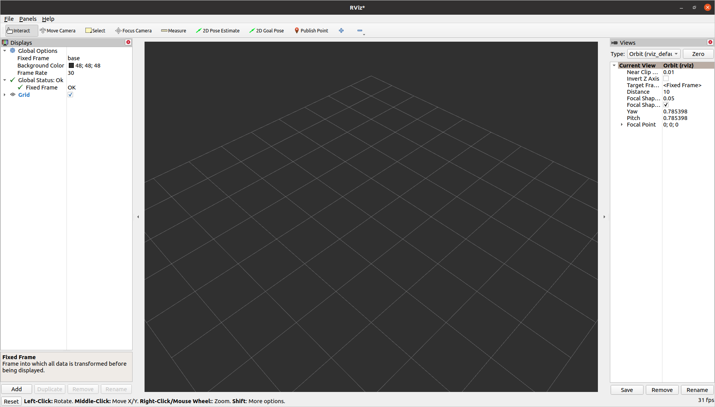

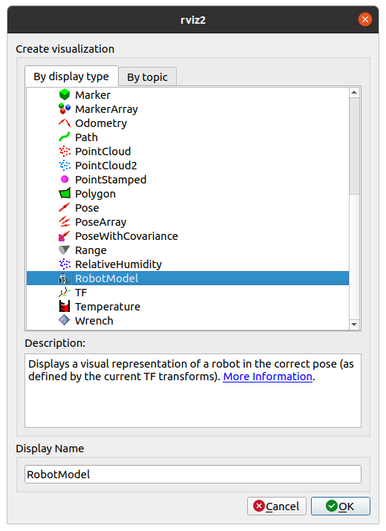

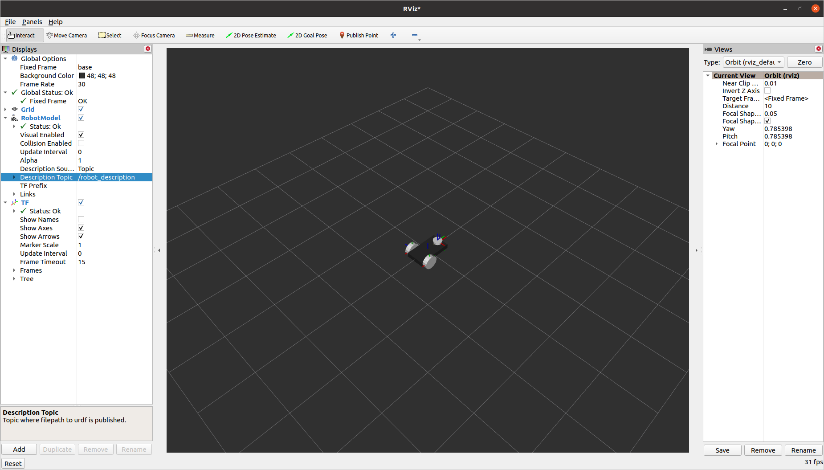

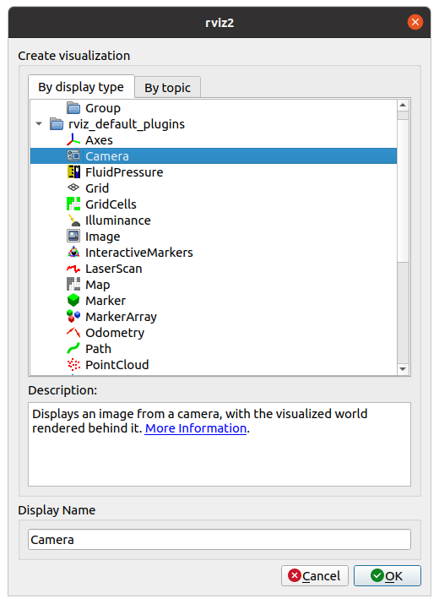
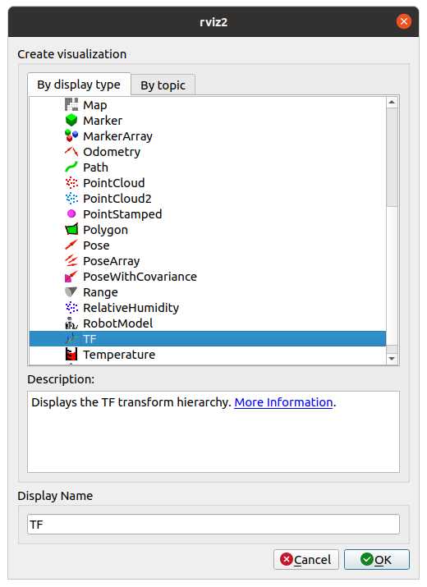

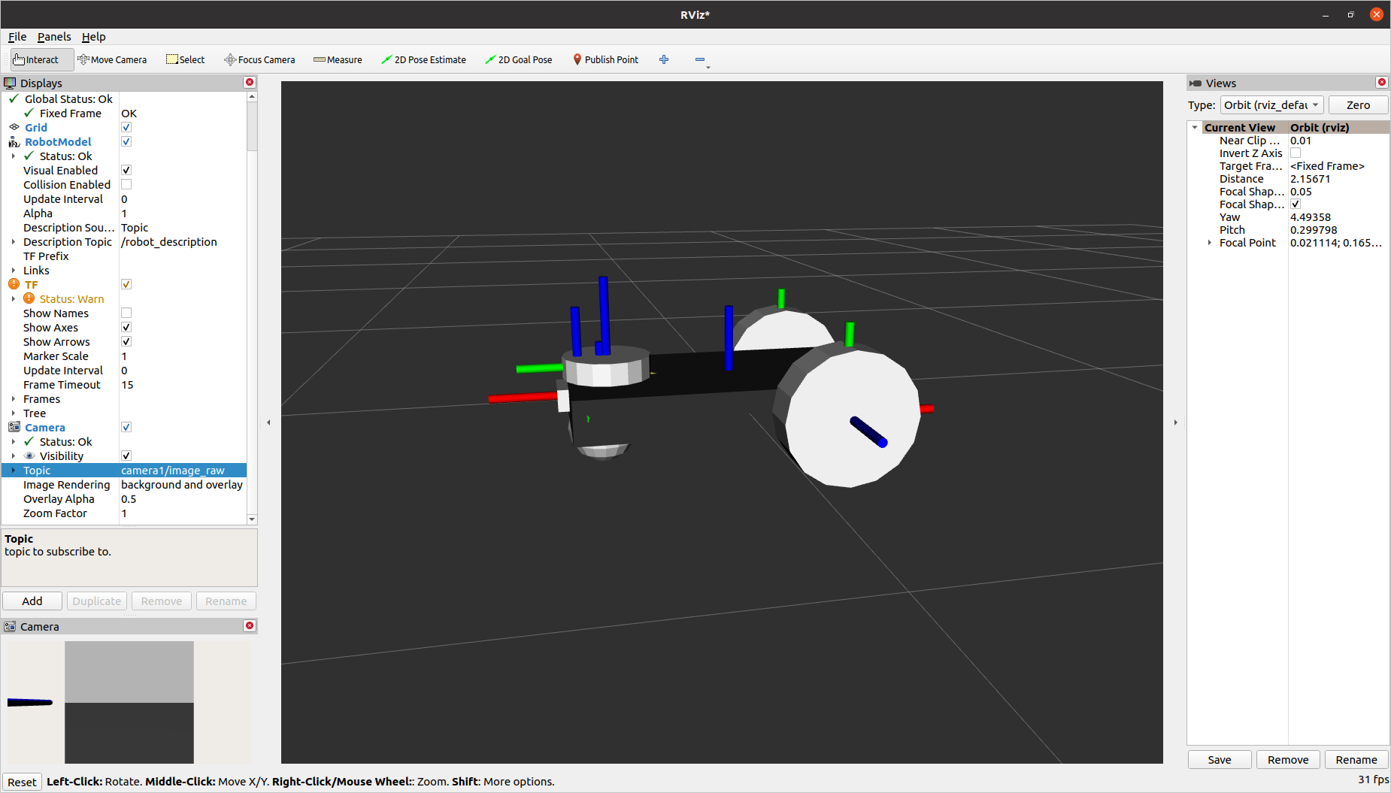

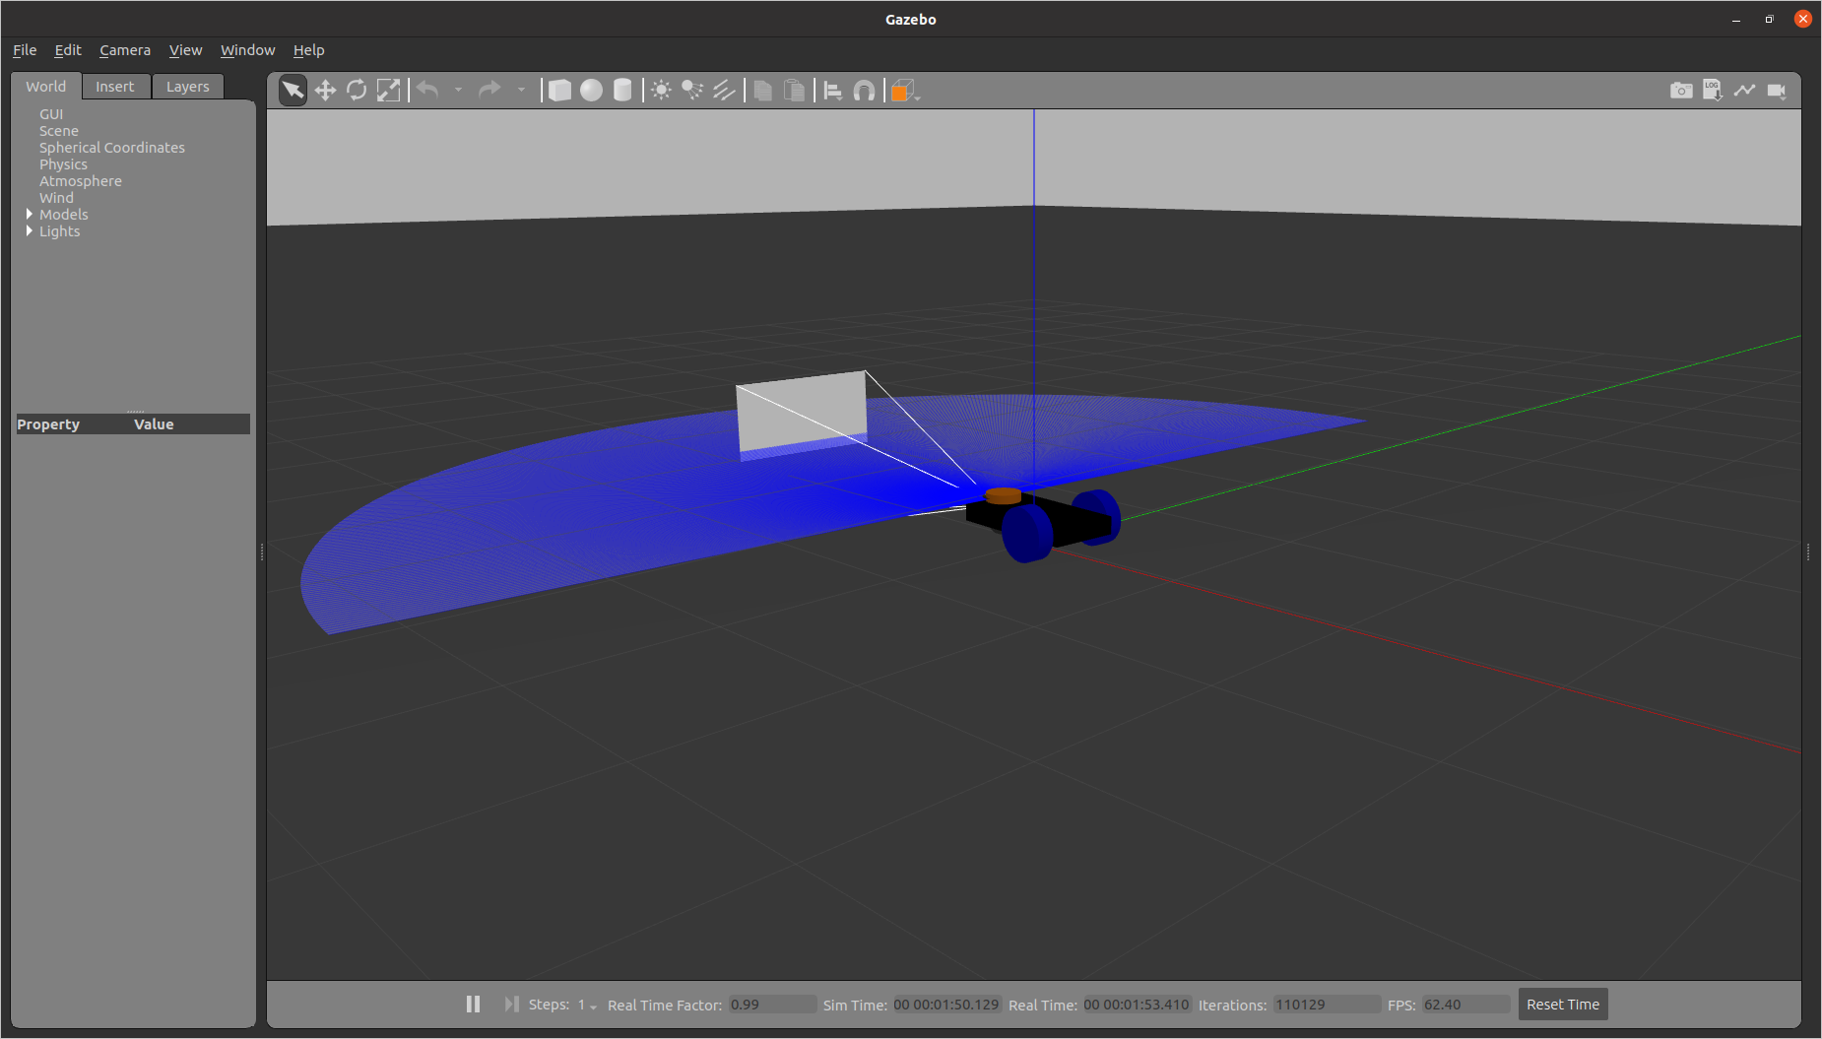

sudo apt-get install python3-pip
pip3 install transforms3d

Edit move_robot.py

#!/usr/bin/env python3
import rclpy
from rclpy.node import Node
from geometry_msgs.msg import Twist
from nav_msgs.msg import Odometry
import transforms3d
import math

class GotoGoalNode(Node):
def __init__(self):
super().__init__("move_robot")
self.target_x = 2
self.target_y = 2
self.publisher = self.create_publisher(Twist, "cmd_vel", 10)
self.subscriber = self.create_subscription(Odometry, "odom", self.control_loop, 10)

def control_loop(self, msg):

dist_x = self.target_x - msg.pose.pose.position.x
dist_y = self.target_y - msg.pose.pose.position.y
print('current position: {} {}'.format(msg.pose.pose.position.x,msg.pose.pose.position.y))
distance = math.sqrt(dist_x * dist_x + dist_y * dist_y)
print('distance : {}'.format(round(distance, 3)))

goal_theta = math.atan2(dist_y, dist_x)
quat = msg.pose.pose.orientation
roll, pitch, yaw = transforms3d.euler.quat2euler([quat.w,quat.x,quat.y,quat.z])
diff = math.pi - round(yaw, 2) + round(goal_theta, 2)
print('yaw: {}'.format(round(yaw, 2)))
print('target angle: {}'.format(round(goal_theta, 2)))

if diff > math.pi:
diff -= 2*math.pi
elif diff < -math.pi:
diff += 2*math.pi
print('orientation : {}'.format(round(diff, 2)))

vel = Twist()

if abs(diff) > 0.2:
vel.linear.x = 0.0
vel.angular.z = 0.4*round(diff, 2)

else:
if abs(distance) > 0.2:
vel.linear.x = 0.3*round(distance, 3)
vel.angular.z = 0.0

else:
vel.linear.x = 0.0
vel.angular.z = 0.0

print('speed : {}'.format(vel))
self.publisher.publish(vel)

def main(args=None):
rclpy.init(args=args)
node = GotoGoalNode()
rclpy.spin(node)
rclpy.shutdown()

if __name__ == "__main__":
main()

Execute in Terminal #1
colcon build --packages-select lab4
ros2 launch lab4 rviz.launch.py
Execute in Terminal #2
killall gzserver
ros2 launch lab4 gazebo.launch.py
Execute in Terminal #3
ros2 run lab4 controller

Edit setup.py

entry_points={
'console_scripts': [
'controller = lab4.move_robot:main'
],

Exercise 1: Create a robot model for the following specifications and move the robot in gazebo environment using keyboard.

Compute the offset, inertia for the given specifications.

Specs for the robot:

Chassis
-box (0.6, 0.8, 0.1)
- color: red

- left_wheel link:
- cylinder (radius 0.1, length 0.05)
- color: blue
- chassis_left_wheel_joint
- continuous joint
- x origin offset: ---(calculate)
- y origin offset: ---(calculate)
- caster_wheel_link:
- sphere (radius 0.1)
- color: white
- chassis_caster_wheel_joint:
- fixed joint
- x offset: 0.2
- z offset: to compute
- chassis_footprint:
- empty link
- chassis_joint:
- parent: chassis_footprint, child: chassis_link
- fixed joint
- offset: (calculate)

Exercise 2: Write a python code to detect the obstacle using laser scan data.

Exercise 3: Modify the URDF code to change to a 4 wheeled robot and run the program.

